**Course9--Tracking**

You need to follow the steps below to build blocks.

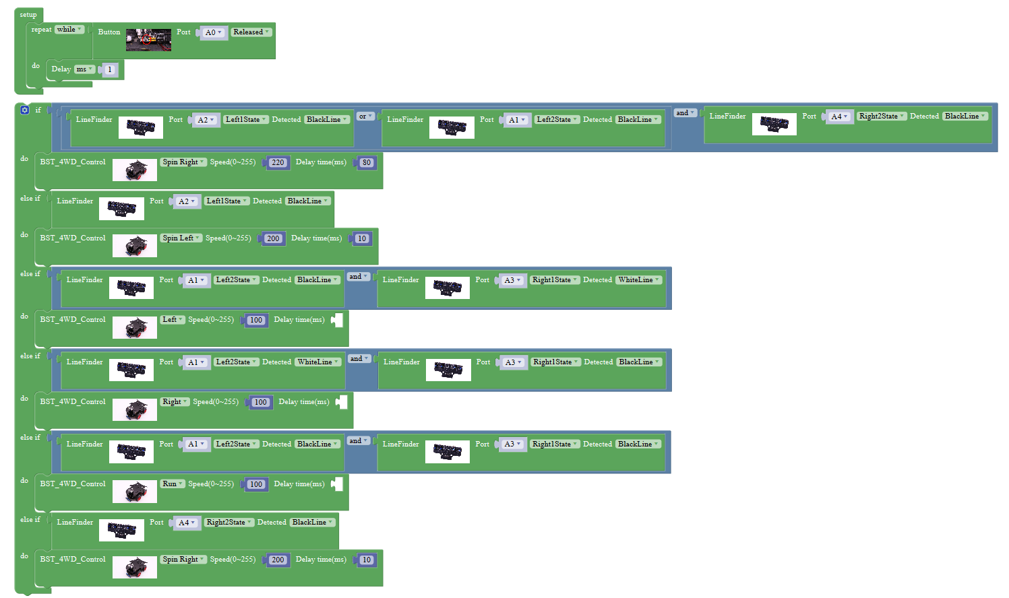

**Steps of experiment:**

1.You need to choose the building blocks which you need for this experiment, as shown in the figure below.

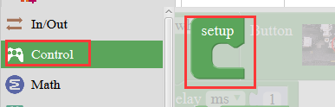

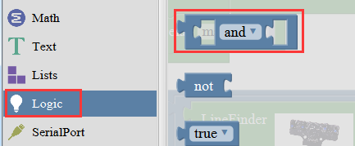 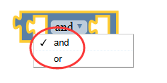

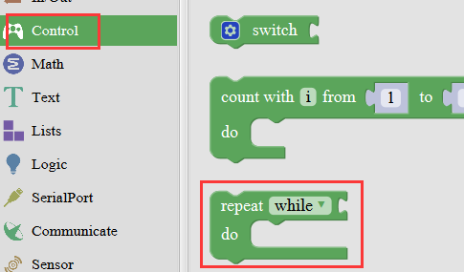

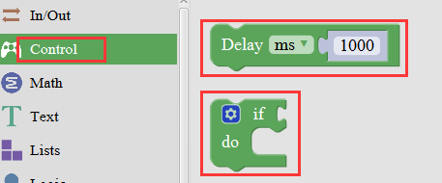

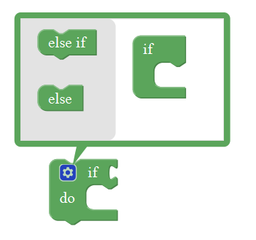 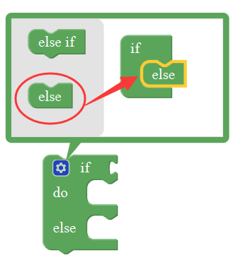

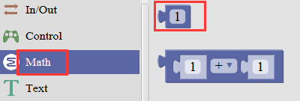

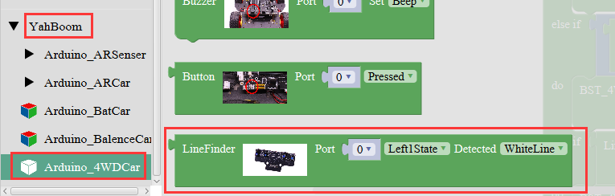

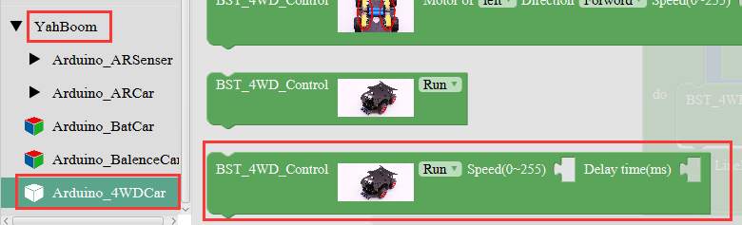

2.You need to combine the selected blocks, as shown in the figure below.



3.You need to you need to click “**Compile**”. and wait for the completion of the compiler, the following box will prompt the compiler successfully, if prompt the compile failure is the problem of building block splicing.

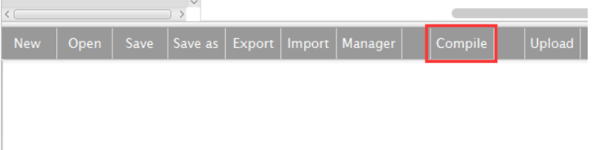

1. After the compilation is completed, the word "**Compile success!**" will appear in the lower left corner, indicating that you have successfully compiled the program.

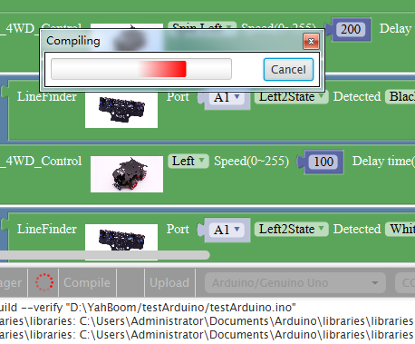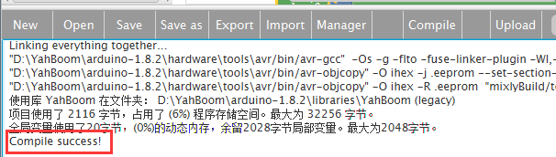

1. In the menu bar of Mixly, we need to select the port that the serial number displayed by the device manager (for exmaple:COM6) and **Arduino/Genuino Uno.** As shown in the figure below.

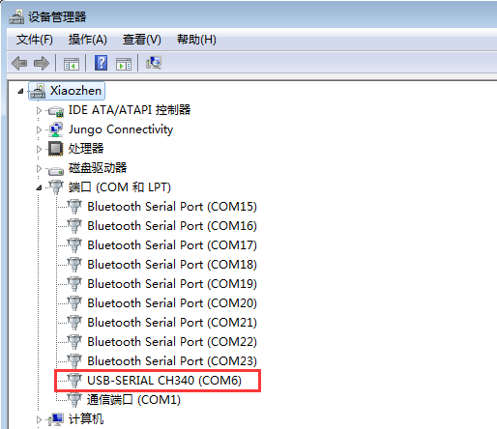

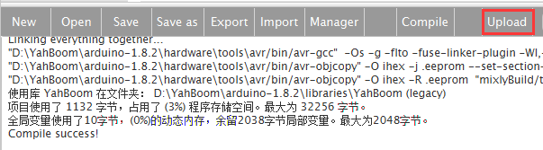

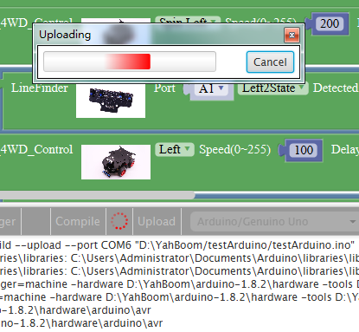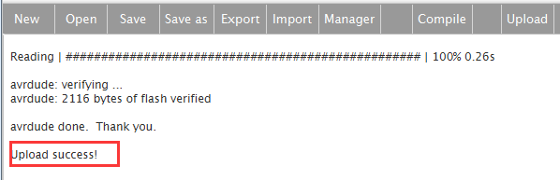

7.After the code is uploaded. You need to press the K2 to start the car, and the tracking function is started. The car will automatically walk along the black line.